CALL FOR ABSTRACT SUBMISSIONS
SUBMIT YOUR ABSTRACT HERE
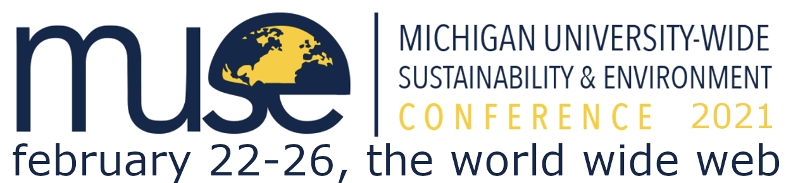

The MUSE Organizing Committee* cordially invites our colleagues at the University of Michigan to participate in the 2021 Michigan University-wide Sustainability and Environment (MUSE) Virtual Conference, to be held online February 22nd -26th, 2021.

The annual flagship event of the MUSE Initiative, the MUSE Conference provides a unique venue for sharing research, building new connections, and fostering interdisciplinary collaboration among all members of the University of Michigan community engaged in a broad range of sustainability and environment-related research. While the event will look a bit different this year as we move to a virtual format, MUSE is committed to finding fun and creative ways to bring people together around this year’s theme of Racial Justice in and for Sustainability and the Environment. We welcome the involvement of U-M undergraduate and graduate students, as well as University staff, faculty, and research fellows from all disciplines, including those in arts, humanities, engineering, and natural and social sciences.

You can participate in the 2021 MUSE Virtual Conference by submitting a short abstract. We encourage submissions to present either specific research outcomes or broader themes related to your research interests. Both oral and poster presentation opportunities are available. Short-form oral presentations may be used to share preliminary results or brief research summaries, while longer presentations allow for more depth. Additionally, we are accepting pre-formed panels; see website for more details. We also are offering a new way to present earlier-stage material to peers across fields in a Working Paper Workshop, in which participants will share working papers or projects of 5 pages or less (double-spaced) and engage in a group discussion focused on the emergent ideas of the circulated papers. While working paper workshops and oral presentations will be live, poster sessions will leverage asynchronous uploads of your poster as well as synchronous discussion groups and live chat interfaces to keep things engaging.

The deadline for abstract submission is November 16, at 11:59pm. Please submit your abstract here.

The 2021 MUSE Virtual Conference will consist of an exciting combination of poster sessions, live oral presentations, themed panels, and working paper workshops. For more information, please go to our conference gateway: http://muse-initiative.umich.edu/conference/.

For questions concerning the MUSE Initiative, the MUSE Conference, or your abstract submission, please write to muse-conference@umich.edu. Please feel free to pass this invitation along to colleagues that you think might be interested.

Sincerely,
*MUSE Organizing Committee 2021:
Surabhi Balachander, English Language and Literature
Cailin Buchanan, Chemical Engineering
Adam Benjamin Smith, Romance Languages and Literatures
Tiffany Dias, School for Environment and Sustainability
Alan Fossa, Epidemiology/School of Public Health
Zachary Gersten, Nutritional Sciences/School of Public Health
Jeremy Glover, English Language and Literature
Elizabeth Ludwig-Borycz, Nutritional Sciences/School of Public Health
Tessa Swanson, Industrial and Operations Engineering
Valerie Washington, Industrial and Operations Engineering

